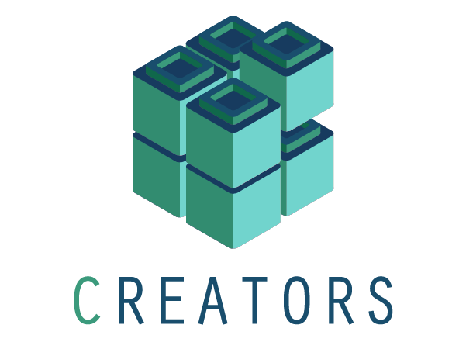

Application Form
CREATORS Open Call for proposals

─

Summary of the Proposal

Title of the project
Maximum 100 words

Description of the project
Maximum 3000 words

Motivation to promote the project
Maximum 1000 words

Beneficiary
For a single entity:

Single Entity
Legal Entity Name(*)
VAT Number
Type of Entity | Physical or legal person, public entity, private entity, energy community, other
Legal Address (*)
Contact Person Full Name (*)
Contact email(*)
Country of reference*

Project Description

General Information of the site

Details of the site
Country
City/Village
Population of the City/Village
Description of the local context
Describe the main challenges of the area

Description of the Generation Assets
Describe the generation assets located at the site that will be involved in the Community Energy System project. Describe the current assets and the ones that are planned to be installed within a period lower than 1 year.

Identification (1) | Type of energy generated /installation | Installed Capacity (kW) | Installed or planned? | Date ( installed or planned) (2)
- Identification of the installation, can be a code, a number, a name,etc ( avoid personal information such as a person’s name)
- For planned assets, please indicate when it is planned to be installed

Description of the participants of the project (future members of the Energy Community) - consumption points
Describe the consumers located at the site that will be involved in the Community Energy System project:
Identification (1) | Profile (Residential, Commercial, Industrial) | Contracted Power (kW) | Annual Energy Consumption (kWh) | Other comments (2)
- Identification of the installation, can be a code, a number, a name,etc ( avoid personal information such as a person’s name)
- Non-personal information

Description of other assets ( storage or other flexibility assets)
Maximum 200 words

Describe the type of energy community
Describe the type of energy community that would better fit the project.
Maximum 200 words

Describe the support requested by CREATORS
Maximum 500 words

Expected Outcomes of the project

Potential Impacts ( Social, Environmental and Economical Impacts)
Maximum 2000 words

Project Replicability
Maximum 500 words

Data Collection
To be granted the CREATORS' study, data must be available to perform the study and must be provided by the applicant. Please indicate what kind of data can be collected.

Generation Data
Describe the generation data that could be provided:

Identification  (1) | What kind of data? (15-min data, hourly data, etc) | Format of the data (csv, excel, txt, etc) | Comments (2)
- Use the same identification provided in section 3.2
- Only comments related to the availability of data, time frame or formats

Consumption Data
Describe the consumption data that could be provided:

Identification  (1) | Can you provide energy bills? | What kind of data? (15-min data, hourly data, etc) | Format of the data (csv, excel, txt, etc) | Comments (2)
 | YES/NO
 | YES/NO
 | YES/NO
- Use the same identification provided in section 3.3
- Only comments related to the availability of data, time frame or formats

Other Data
Describe other useful non-personal data that could be provided for the development of the study.

